**Creating accessible Microsoft Word documents**

It is important to provide accessible documents. We use documents for communicating about scholarship, events, work, academics, and more.

- Scholarship

- Events

- Work

- Academics

Scholarship

Documents that we create for scholarship demonstrate incredible research and innovation happening at the University of Michigan.

Events

Documents that we create to support, advertise, or script events.

Work

Documents that we create to facilitate work. Some of these documents are widely used at the University of Michigan.

Academics

Documents that support learning experiences at the University of Michigan. Maybe we should utilize a different color: <https://brand.umich.edu/design-resources/colors/>.

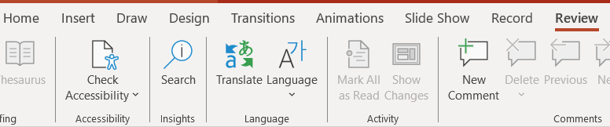

# Book Title

## Chapter 1

## Chapter 2

## Chapter 3

### Subchapter 3.1

### Subchapter 3.2

## Chapter 4

## Chapter 5

# 